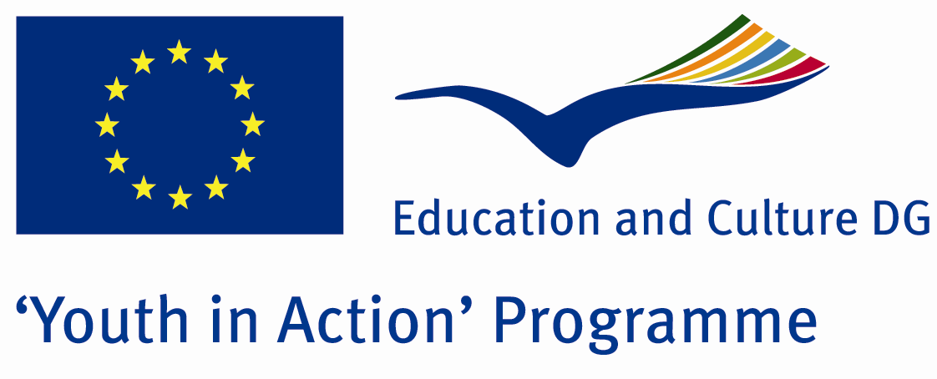

The Ceremony of Military Duty

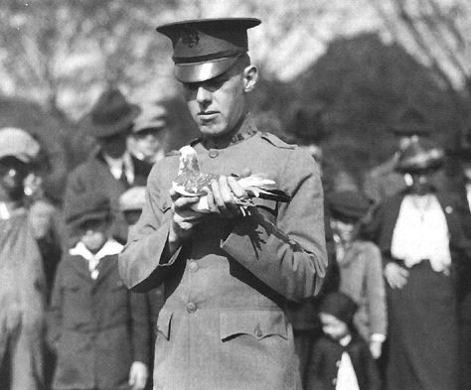

ACTION 1.1 – Youth Exchange

01-08th August, 2011

Tekirdag/TURKEY

Please contact directly to;

adventurerpeacepigeons@gmail.com

Project Summary;
We are doing Project about army duty and festivals of sending a boy to Army duty. In Turkey, while a boy is going to army for army duty, we do some festivals like wedding. Here, our project is about these festivals… When you participate to our project, you will see these festivals. These are not public festivals… It is for the soldiers’ relatives and friends… Already they do this festival for the soldier. We are curious that what your country’ opinions about army duty and do you have some festivals like this or some feast for army duty… For example, in your country, when a boy goes to Army Duty, does he go to there like a travel… For these things and fun and culture exchange and holiday and see Turkey, do you want to participate us??? Then, send your application form ☺ ☺ ☺

Project Title; The ceremony of military duty

Date and Venue ; 01-08th August, 2011 Tekirdag/TURKEY

Target Group; Non profit/non governmental organization, Public body, Body active at European level in the field of youth (ENGO), Informal group of young people, e.t.c…

Participants; 5 people from each country (18 - 25). Totally 8 countries.

Conditions; Accommodation, board and programme costs will be financed through European Commission Youth in Action Programme (Action 1.1). Travel costs will be reimbursed in 70% (APEX Tarrifs). Organizations from all 27 EU member countries plus Liechtenstein , Norway and Iceland are eligible to take part.

Working language: English

Organizer; Discovery And Adventure Group

How to apply: If you are interested, please send your Part III forms to
0090 216 483 21 67 by FAX please. (Fulfilled Part III which you can find in the attachment, of course signed and stamped) ..

Note: jpeg is not allowed..please send by fax…

Next step 2;
Original send via regular post to this address please:

Ertan DERİN
Öner İnşaat
Abdulhalik Renda Cd.
Parlar Sk. No:4 Pendik/İSTANBUL

If you have any questions you may contact with: adventurerpeacepigeons@gmail.com
Deadline for application; until 20th January 2011.
For Further information:
Contact Person
Ertan DERİN
Öner İnşaat
Abdulhalik Renda Cd.
Parlar Sk. No:4 Pendik/İSTANBUL

e-mail : adventurerpeacepigeons@gmail.com
Mobile : 0090 542 393 93 90
Fax : 0090 216 483 21 67

